Game User Research on 2.5D Isometric Game Focusing on Magic Skills

| Ahmet Dara VEFA  Middle East Technical University  Ankara, Turkey  e223789@metu.edu.tr |
| --- |

# ABSTRACT

Paste the appropriate copyright/license statement here. ACM now supports three different publication options:

* ACM copyright: ACM holds the copyright on the work. This is the historical approach.
* License: The author(s) retain copyright, but ACM receives an exclusive publication license.
* Open Access: The author(s) wish to pay for the work to be open access. The additional fee must be paid to ACM.

This text field is large enough to hold the appropriate release statement assuming it is single-spaced in Times New Roman 8-point font. Please do not change or modify the size of this text box.

Each submission will be assigned a DOI string to be included here.

Orphan’s Dream is a 2.5D isometric game that has two types of skills. There are normal skills and there are elemental magic skills. Elemental magic skills are a lot more powerful than normal skills, but they cost much more mana and have longer cooldowns.

There are four elements in the game: “Polar”, “Scorch”, “Star” and “Thunder”. Each of these elements have unique damage, projectile speed, and cooldown multiplier. Each element also has unique magic skill effect.

I conducted interviews to understand if users like or dislike the unique properties and visuals of these elements and why they think this way.

## Author Keywords

Game user research; game user experience; user interview

## ACM Classification Keywords

•Human-centered computing~Human computer interaction (HCI)~HCI design and evaluation methods~User studies

# INTRODUCTION

You can play the test version of the game from [this link](https://venediklee.github.io/OrphansDreamWebGL). Please note that the link won’t be available after some time.

The test version of Orphan’s Dream gives players 4 skills, default melee and default ranged attacks. Within the 4 skills 3 of them are normal skills and 1 of them is an elemental magic skill.

The first normal skill is called “Homing Arrows”. When “Q” key is pressed an arrow is launched towards the mouse position. The launched arrow then tries to home in on an enemy. Unfortunately, this skill was a bit buggy because sometimes the arrows would not home in correctly. This skill deals a tiny bit less damage than default attack(s) but consumes a tiny bit of mana.

The second normal skill is called “Boomerang Slash”. When “W” key is pressed a sword spawns on the character and moves towards the mouse direction while spinning around itself. After moving a certain distance, the sword comes back to the player in a certain time. The sword also spins while turning back. The sword damages any enemy during its travel and if used correctly it can damage the same enemy multiple times. This skill deals damage a tiny bit more than default attack(s) and consumes small amount of mana.

Third, and last, normal skill is called “Flicker Strike”. When “E” key is pressed the character is moved towards the mouse position a certain distance. All enemies that are between the old and new position get damaged only a small amount. Also, this skill consumes a tiny bit of mana.

The elemental magic skill is called “’Element’ Bolt”. When “R” key is pressed an element bolt that has the active element’s properties and visuals get spawned on the character and moves towards the mouse position. This skill has huge amounts of base damage and consumes moderate amount of mana.

To change the active element, you must press the “ESC” key, select one of the elements and press “ESC” key to close the menu. Note that this menu is bugged as it sometimes won’t show the elements, to see the elements please hold right click .

You can see this menu in Figure 1.

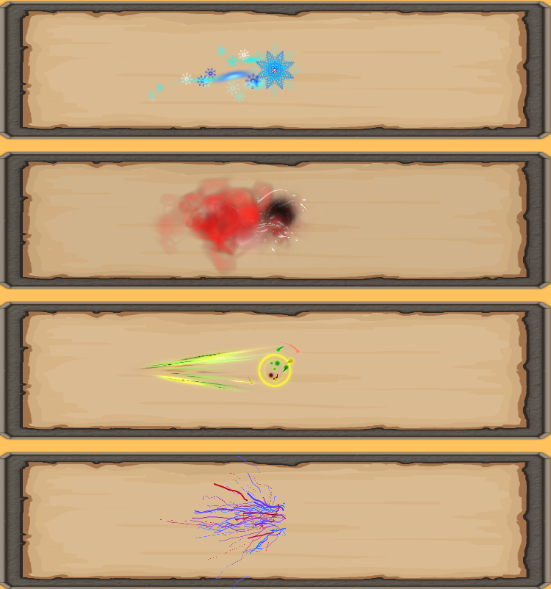

Figure . Elemental visual effects on “Element Bolt” skill

The player can attack by left clicking the mouse. By default, user attacks with melee but can swap to ranged attacks by clicking spacebar and vice versa. The melee attack and ranged attack are both towards the mouse direction and don’t consume any mana.

When right click is held, player will move towards the mouse direction. In addition to this, player can move to mouse position by releasing right click. This gives the player freedom to attack in a different direction while moving.

The enemy AI is primitive such that they will try to get close to you and try attacking you. There are both ranged enemies and melee enemies.

Starting scene is the training scene and will restart if the player dies or kills all enemies. To move to next scene(s), you should press the “N” key. Note that the frozen cave scene has a bug that prevents camera from following the player.

# Intervıew structure & questıons

I conducted 4 interviews. Interviewees were a “game addict”(Utku), a “gamer”(Bahadır), a “game maker”(Cemile), and a “casual gamer”(Baran).

The interviews were open ended; the interviewees were encouraged to talk about more than what was asked.

At the start of the interviews I talked about what the game is and how the interview will happen.

You can watch the interview with the “casual gamer” from [this link](https://youtu.be/xe-PMMVAhJA) but it is made using the Turkish language.

Interviews were done online and out of the 4 interviews only the one with the “casual gamer” had connection issues. In addition to this “gamer’s computer had technical issues as his game was running in a constant low FPS.

Interview questions were prepared and asked in Turkish. However, in the following sections I will translate them to English, explain why the question was asked, and give a quick overview of the answers.

### Q1 Which element will you try first, which element will you try last?

This question aims to understand players first impression on the elemental visual effects. Most interviewees tried the coolest looking elements first while some of the interviewees did it in order.

### Q2 If you were to give points out of 10 to elements based on visuals what would you give them? Could you explain why they look good or bad? What would you change about them?

This question forces the interviewees to think why they like or dislike the elemental effect. Furthermore, the question aims to receive immediate feedback on how to improve or change the elemental effects. Interviewees gave different examples of what they would change.

### Q3 How are the controls? Do they feel natural? Is it hard to use skills and items? Would you change the buttons?

The aim of this question is to understand if players are comfortable with the key mappings and if they are ready to play the next levels. About half of the interviewees thought that moving with WASD would be better.

### Q4 Did you find any combo moves during training?

This question tries to find out if players can naturally find combo moves. None of the interviewees found the combo move.

### Q5 Did your interest or love to elements change after trying the elements?

This question tries to understand if players can easily get bored of an elemental effect or if they get to like the elemental effect more. About half of the interviewees opinions on some elements changed after time.

### Q6 Was there an overpowered element?

This question tries to find if people can feel the difference in damage multipliers of elements. Interviewees thought that damage was similar in all elements and they had not felt much difference.

### Q7 Did you select your favorite element because it looked cool or because it was overpowered?

This question aims to find if people change their thoughts on elements after finding out one of them was overpowered. As no interviewee reported an overpowered element, this question was somewhat useless.

### Q8 Would you like it if there were elemental aspects to the magic skills like freezing, burning, piercing, zapping?

This question aims to find if people want elemental aspects in the game and if so, what kind of aspects they expect from each element. All the interviewees repeatedly expected and wanted elemental aspects in the game.

### Q9 What are your thoughts on elemental magic skills and normal skills?

This and the next 2 questions are final questions and aim to ask general questions about the game. These questions require no further explanation.

### Q10 What was the worst part of elemental magic skills and normal skills? Why?

### Q11 Is there anything you would like to say about the game I have not given you the chance to?

# Hypotheses

## Hypothesis 1

H0: Users notice elemental differences by its damage, projectile speed, and cooldown multipliers.

H1: Users do not notice elemental differences by its damage, projectile speed, and cooldown multipliers.

## Hypothesis 2

H0: Users understand and like elemental visual effects.

H1: Users do not understand nor like elemental visual effects.

# lıterature search

Currently there are no previous papers I could find about user research on magic skills in games. The most relevant resource I could find is a book called “Game Magic: A Designer's Guide to Magic Systems in Theory and Practice” by Jeff Howard and it is not freely available nor does it relate that much with any of my hypotheses.

# Analysıs Method

The data gathered from the interviews are qualitative data, not quantitative. So, it is not applicable to use statistical data analysis techniques. Therefore, I used thematic analysis to process the data from the interviews.

The codes used in the coding of data can be found in Figure 2 or in the attachments folder along with excel sheets. 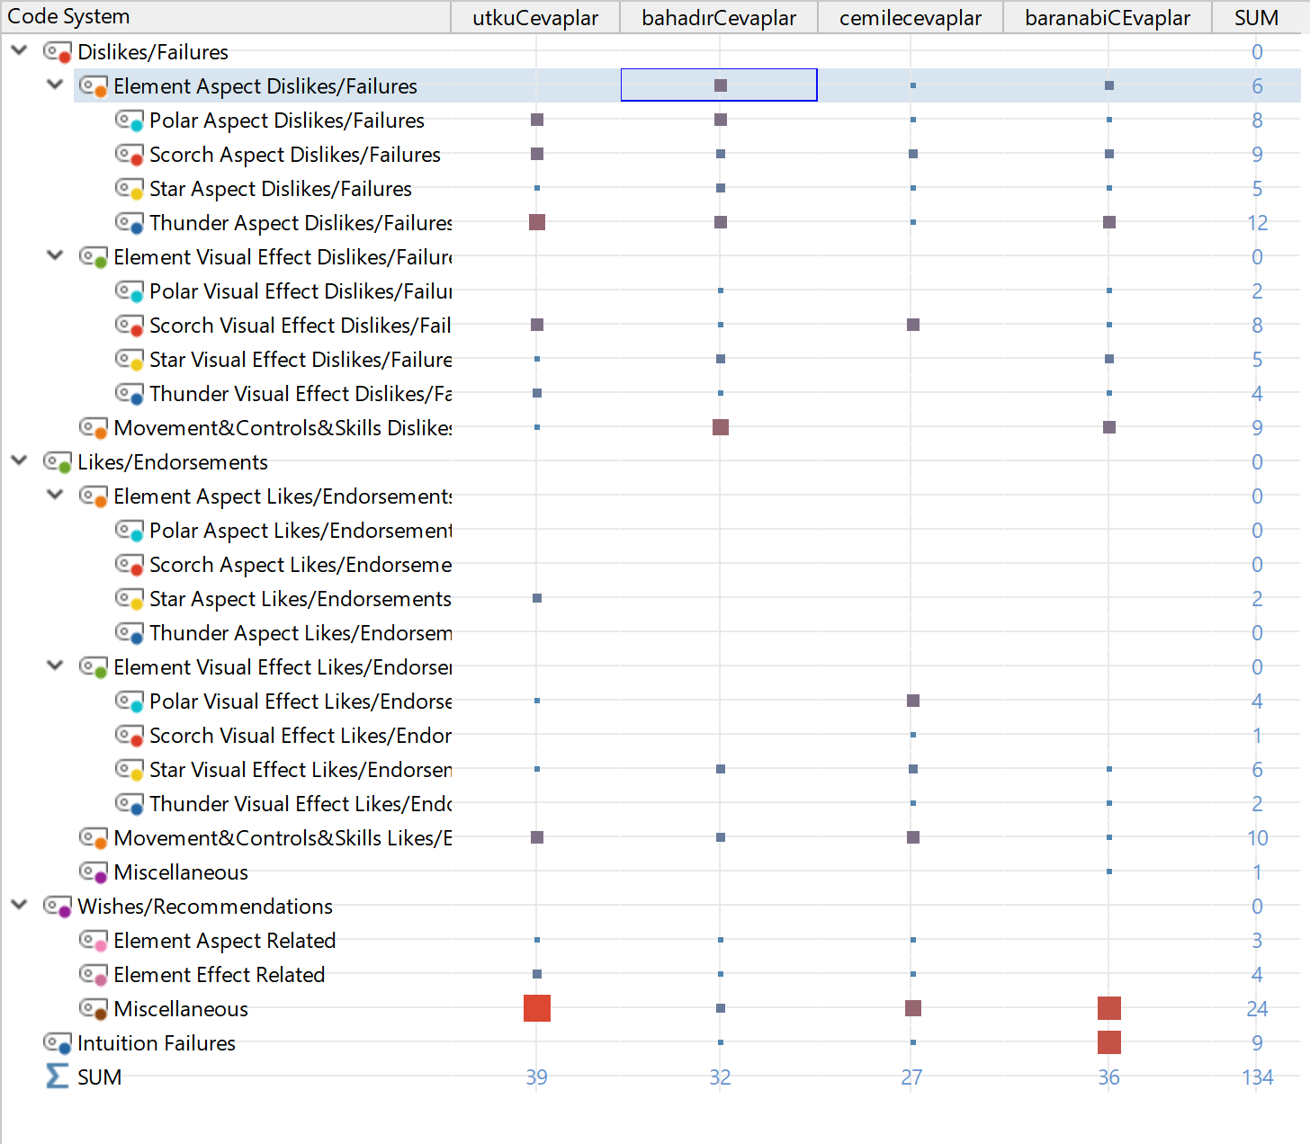

Figure . Code matrix Extended

The coding structure was chosen like this to help me find problems with specific elements. Also note that the “SUM” part does not take weights of coded segments into account. For weighted sums please see “Reduced data” sheet of “Coded Segments.xlsx” file. More information on this can be found in report section of this paper.

One important note is that “Element Aspect Dislikes/Failures” and all child codes include interviewee comments about why and what they want from the element aspects. For example, “scorch should burn the enemies” comment is in “Scorch Aspect Dislikes/Failures”.

You can access the MAXQDA project from the attachments with “TermProject.mx20” file. Optionally you can see all the coded segments, weights, associated code, and comments in the “Raw data” sheet of “Coded Segments.xlsx” file.

# Report

This section will include analysis of the “Reduced data” and “Raw data” sheets of “Coded Segments.xlsx” file. I will first talk about total weight scores of element related codes and code groups. Then I will continue with the findings from the raw data. Later I will do the same for rest of the codes and code groups.

When we first look at the “Dislikes/Failures->Element Aspect Dislikes” and its child codes we see that they have a huge weight. In contrast to this only “Likes/Endorsements -> Element Aspect Likes/Endorsements” has a tiny amount of weight which is coming from “Star Aspect Likes/Endorsements”. This tiny amount of weight is coming from one user saying, “star bolt is cost effective”. If we look at the weights in more detail; polar, scorch and thunder has the exact same total weight on aspect dislikes/failures at 22 points, while star has 6 points on aspect dislikes/failures. This is a clear indication that users want elemental aspects to be in the game. Furthermore, since star is the only element that has aspect likes/endorsements but has a moderately low aspect dislikes/failures, we can deduce that users want elemental aspects to be noticeable compared to other elements. This deduction comes from star element being mentioned as cost effective compared to other elements, along with other comments saying, “these elemental aspects should be quite different with each element”.

For the visuals let’s check “Dislikes/Failures -> Element Visual Effect Dislikes/Failures” and its child codes along with “Likes/Endorsements -> Element Visual Effect Likes/Endorsements” and its child codes. Element visual effect dislikes has a total of 35 weight while, likes has a total weight of 26. As both weights are high we need to look at the child nodes individually.

Polar visuals have 3 dislikes and 10 likes. The dislikes come from “small ice effects don’t look like they are moving much” and “central polar effect does not look like a polar flake” comments. So, users want ice particles to move faster and make the central effect more like ice flake.

Scorch visuals have 15 dislikes and 2 likes. Dislikes come from comments indicating scorch is ugly, its colors are ugly, and it does not look alive while the likes come from a user saying he/she started liking it more after trying it. This basically means that scorch effect looks ugly at first sight and is not fulfilling users’ expectations from scorch with the way it looks.

Star visuals have 9 dislikes and 11 likes. Dislikes are from comments indicating its colors are not real star colors, the tail effect is a bit bigger than the central effect, and it loses its vibrant colors on light backgrounds. On the other hand, likes are from comments indicating it has a nice geometry, it is cute, and the central particles are nice but there could be more central particles. So, users want star effect to be have better, more real colors while keeping the overall geometry the same.

Thunder visuals have 8 dislikes and 3 likes. Most users said they do not like the effect because it has reddish colors and they expected bluer and more turquoise colors. While one user said the thunder rods are too much and it looks like confetti, another user said the thunder is like thunder and it is nice. Basically, users want thunder colors to be more turquoise, less red.

For the movement & controls & skills (MCS) dislikes/failures and likes/endorsements we have 14 dislikes and 21 likes. As these are vague codes we must look at the raw data for these codes.

The dislikes/failures about MCS are about:

* not finding a combo,
* boomerang slash not having less cooldown when caught with flicker strike,
* flicker strike not moving to mouse position but instead moving towards mouse position,
* people preferring movement with WASD keys,
* moving and attacking being repetitive and hard.

The likes/endorsements about MCS are about:

* controls and button placements being nice,
* movement being easy,
* being able to press all the skills at once,
* skills being nice/cute,
* game having combos.

These data indicate that users like skills that match with one another, users need time to adjust to a non-familiar movement style, and users want skills to be more controllable(like moving up to mouse position with flicker strike).

Intuition failures are when a user expects something, but it does not happen. These failures are:

* hitboxes being too small,
* dangerous environment damaging the player. For example, players expect to be damaged when they fall into lava,
* UI indicating the active element,
* not realizing normal attacks,
* failing to understand movement styles,
* not understanding projectile ranges.

This data indicates users want larger hitboxes, users want environment to be able to damage characters, users want UI to indicate active element, and users need a proper training to understand the game mechanics.

There was a single miscellaneous comment saying that the UI layout is nice.

Users had a multitude of wishes/recommendations. Repeated wishes(by the same user or different users) include:

* mobile version of the game,
* dynamic environment,
* character classes,
* ability tree,
* drops/chests/breakable objects in maps

For details and rest of the wishes please see the relevant section in “Coded Segments.xlsx” file.

# results

First null hypothesis was wrong. Some of the users barely noticed elemental damage, projectile speed, and cooldown differences but all of them agreed that this difference was not enough for them to have a solid opinion.

Second null hypothesis was mostly wrong as users disliked some parts of the visual effects a lot and wanted small changes in some parts.

# conclusıon

This game needs to implement elemental aspects other than damage, projectile speed etc. There should be unique effects of each element like freezing or chilling/slowing for polar, burning or exploding for scorch, piercing or ricocheting from surfaces for star, zapping or shocking/charging for thunder. Each of these aspects should be unique such that there should not be 2 elements that does damage over time.

The game should teach users how to play the game gradually.

Scorch and thunder visuals need to change according to underlined segments in the report section of this paper.

The game should take the underlined segments seriously as they are repeated problems, issues, and needs of the users.

I hope this paper can help future interviewers design their interviews focusing on skills.

# ACKNOWLEDGMENTS

I would like to thank all the interviewees as they received no payment for the interviews.

# REFERENCES

1. O'Connor, H. & Gibson, Nancy. (2003). A Step-By-Step Guide To Qualitative Data Analysis. Pimatisiwin: A Journal of Aboriginal and Indigenous Community Health. 1. 63-90. Retrieved July 1, 2020 from https://www.researchgate.net/publication/292432218_A_Step-By-Step_Guide_To_Qualitative_Data_Analysis